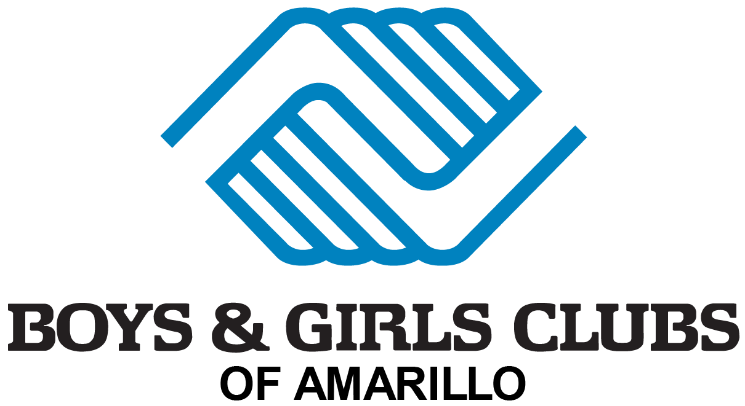
2017-2018 School Schedule
- August 2017
  - August 16th --first day of school
- September
  - September 4th – labor day (closed)
- October
  - October 6th -(open all day)
  - October 9th -(closed 4 staff training)
- November
  - November 22nd (open all day)
  - November 23rd-24th (closed)
- December
  - December 22nd (half –day)
  - December 25th -through 29th (closed)

- January 2018
  - January 1st through 5th (closed)
  - January 15th (closed)
- February
  - February 16th (open all day)
  - February 19th (closed 4 staff training)
- March
  - March 12th through 16th (spring break club open all day)
  - March 30th (closed)
- April
- May
  - May 25th last day!
  - May 28th (closed)

